**Additional Exercises - Basic PHP - II**

**Acknowledgement:**

* These **29** exercises are adapted from exercises that are part of IS111 (Introduction to Programming) labs
* Not all questions of all labs are included
* Lab 7 (file reading and writing) is omitted

**Objectives:**

* Many students seem to require more practice to get used with PHP syntax
* To help everyone better understand and get familiar with PHP syntax, we create a set of exercises that most students know how to solve using Python.
* Through these exercises, we hope that you would learn how to master PHP syntax.

**Resources:**

* Please download resources from: [**https://bit.ly/2SalcHC**](https://bit.ly/2SalcHC)

**Lab 1: Variables**

Learning Outcomes:

* Solve very simple arithmetic problems by using variables referring values of different type
* Get familiar with string concatenation
* Get familiar with using print and input built-in functions

Instructions:

* Suggest that you create a working folder **is111\lab1** in your **C:\wamp64\www** folder. Store all your solutions in this working folder.
* Challenging questions are marked with *.

1. Write a program in a file named **lab1_1.php** that computes and prints out the area and circumference of a circle of a given radius. The radius could be set to an int or float value. You can set the value of π to **3.14**

**Note**: Declare π using a constant with name PI with all capitalized letters to indicate that the value is not to be changed in the code after the initial assignment.

Formulas:

· Area of circle = π X radius2

· Circumference of circle = π X 2 X radius

Here is a sample output when **lab1_1** is run (if radius is set to **4.0**):

|  |
| --- |
| Area of circle of radius 4 cm is 50.24 sq cm  Circumference of circle of radius 4 cm is 25.12 cm |

2. Your weight is actually the amount of gravitational attraction exerted on you by the Earth. On different planets, your weighing scales will show different figures depending on the gravitational force of that planet.

Write a program in a file named **lab1_2.php** that defines a variable to store your weight on Earth. The program then computes and outputs your weight on Mercury, Venus, Jupiter and Saturn. Use this conversion table:

|  |  |
| --- | --- |
| **Planet** | **Multiply the Earth Weight by** |
| Mercury | 0.4 |
| Venus | 0.9 |
| Jupiter | 2.5 |

Here is a sample output of the program (if your weight on Earth is set to **60**):

|  |
| --- |
| Your weight on Earth is 60 kg  Your weight on Mercury is 24 kg  Your weight on Venus is 54 kg  Your weight on Jupiter is 150 kg |

4. In the code given below, complete code that circularly shifts the values of 4 variables a, b, c and d. You are NOT supposed to make use of more than one new variable to accomplish the task. For example, if the variable values (of a, b, c and d) are initially 11, 21, 31 and 41 respectively, then the final values (of a, b, c and d) are 41, 11, 21, and 31 respectively.

Note: you should not hard code the answer, which means that for any value set to variables a, b, c and d, the code written should work without any change.

|  |  |
| --- | --- |
| 01  02  03  04  05  06  07  08  09  10  11  12 | <?php  $a = 11;  $b = 21;  $c = 31;  $d = 41;  echo "before rotation: a = $a, b = $b, c = $c, d = $d";    **# write your code here**      echo "after rotation: a = $a, b = $b, c = $c, d = $d";  ?> |

Here is the output of **lab1_4.php**:

|  |
| --- |
| before rotation: a = 11, b = 21, c = 31, d = 41  after rotation: a = 41, b = 11, c = 21, d = 31 |

5. Write a program in a file named **lab1_5.php** that converts a temperature reading in Fahrenheit (tempInF) to Celsius (tempInC). The formula for conversion is:

(i) Get a value from **lab1_5.html** for temperature in Fahrenheit.

(ii) Store the user input in tempInF, and print out the corresponding temperature in Celsius.

Here is **lab1_5.htm**l:

|  |
| --- |
| <!DOCTYPE html> <html>  <body>  <form action="lab1_5.php">  Temperature in Fahrenheit:   <input type="text" name="tempInF"/>  <input type="submit"/>  </form>  </body> </html> |

Here is a sample output when **lab1_5** is executed (with tempInF = 100.2):

|  |
| --- |
| 100.2 F = 37.888888888889 C |

6. Interest on credit card outstanding amount can be quite high. Some credit card companies compute interest on an *average daily balance*. The credit card issuer determines your average daily balance for the month by multiplying the balance you owe by the number of days you carried it, and dividing by the total number of days in the month. Here is an algorithm for computing the average daily balance and the monthly interest charge on a credit card.

Step 1: Multiply the net balance shown on the credit card statement by the number of days in the billing cycle (i.e. number of days in the month). This is what needs to be paid.

Step 2: Multiply the net payment received by the number of days the payment was received before the statement date. The statement date is always the last day of the billing cycle. Therefore, if payment was received on day 5 of the billing cycle, this converts to 31-5, or 26 days before the statement date. This is what has been paid.

Step 3: Subtract the result of the calculation in step 2 from the result of the calculation in step 1.

Step 4: Divide the result of step 3 by the number of days in the billing cycle. This value is the average daily balance.

Step 5: Compute the interest charge for the billing period by multiplying the average daily balance by the monthly interest rate.

Here is an example. Assume the billing cycle for the month is 31 days, and the monthly interest rate is 1.33%. The credit card statement shows a previous balance of $1,100.00. A payment of $650.00 was made on day 19 of the billing cycle (i.e. 12 days before the statement date). The calculation of the interest charge goes like this:

Step 1: $1,100 x 31 = $34,100

Step 2: $650 x 12 = $7,800

Step 3: $34,100 - $7,800=$26,300

Step 4: Average daily balance: $26,300 ÷ 31 = $848.39

Step 5: Interest charge: $848.39 x 0.0133 = $11.28

Write a program called **lab1_6.php** that computes the monthly interest charged on a credit card account.

Your program must get inputs from **lab1_6.html** for the following:

* previous balance
* payment amount
* day of the billing cycle on which payment was made
* monthly interest rate

You can assume that the number of days in the billing cycle to be **31** (regardless of the month for simplicity). Choose meaningful variable names to store the values.

|  |
| --- |
| <!DOCTYPE html> <html>  <body>  <form action="lab1_6.php">   Enter previous balance:   <input type="text" name="prev_balance"/>  <br/>   Enter paid amount:   <input type="text" name="paid_amount"/>  <br/>    Enter day of payment made:   <input type="text" name="day_payment_made"/>  <br/>    Enter interest rate:   <input type="text" name="interest_rate"/>  <br/>    <input type="submit"/>  </form>  </body> </html> |

Here is a sample output for examples given earlier:

|  |
| --- |
| Previous balance is $1100  Payment of $650 was made on day 19 of the billing cycle  Interest on outstanding amount is $11.283548387097 |

**Lab 2: Conditionals and Iteration**

Learning Outcomes:

* Get familiar with using if-else, if-elseif structures and boolean operators
* Get familiar with using for loop structure

Instructions:

* Suggest that you create a working folder **is111\lab2** in your **C:\wamp64\www** folder. Store all your solutions in this working folder.
* Challenging questions are marked with *.

1. A shop pays its sales staff based on each salesperson’s monthly sales. Each salesperson is paid a basic monthly salary of $2000 plus commission based on the following table:

|  |  |
| --- | --- |
| Monthly sales ($) | Commission rate (%) |
| <10,000 | 5 |
| 10,000 to <15,000 | 10 |
| 15,000 to <18,000 | 15 |
| 18,000 and above | 18 |

Write a program in a file named **lab2_2.php** that does the following:

(i) Receives the salesperson’s monthly sales amount from a suitable html form

(ii) Calculate the salesperson’s commission

(iii) Calculate the salesperson’s pay (i.e. $2000 + commission)

(iv) Display salesperson’s commission rate in percentage and monthly pay.

Write by yourself a simple **lab2_2.html** prompting a user to enter the monthly sales amount.

Here is a sample output of **lab2_2.php** (for monthly sales amount = 14450):

|  |
| --- |
| Entered monthly sales amount($):14450  Commission rate for sale of sales amount 14450 is 10%  The monthly pay for the salesperson is $3445 |

2. Write a program in a file named **lab2_2.php** that simulates a simple jackpot machine. You are given the program’s partial code that generates and shows 3 random numbers (between 1 and 9, including 1 and 9) in a row.

Lines 02 to 04 calls the function in random module to generate 3 random numbers between 1 and 9 and assigns them to variables num1, num2 and num3 respectively. Line 01 enables to call the function from random module.

Complete the program to display one of the following messages: “Try again!”, “2 of a kind” or “Jackpot!” depending on the 3 numbers generated.

|  |  |
| --- | --- |
| 01  02  03  04  05  06  07  08  09  10  11  12  13  14 | <?php  $num1 = rand(1,10);  $num2 = rand(1,10);  $num3 = rand(1,10);    echo "*****************<br/>";  echo "** $num1 ** $num2 ** $num3 **<br/>";  echo "*****************<br/>";    **# write your code here**  ?> |

Here are some sample runs of **lab2_2**: (the random numbers generated could be different)

|  |
| --- |
| *****************  ** 3 ** 2 ** 7 **  *****************  ** Try again! ** |

|  |
| --- |
| *****************  ** 7 ** 4 ** 7 **  *****************  ** 2 of a kind ** |

|  |
| --- |
| *****************  ** 9 ** 9 ** 9 **  *****************  ** Jackpot!! ** |

3. In number theory, a perfect number is a positive integer that is equal to the sum of all its factors excluding itself. For example 6 is a perfect number because the sum of its factors i.e. 1 + 2 + 3 = 6

Write a program in a file named **lab2_3.php** that takes in a positive integer, say 6, from a suitable html form. The program should then check if the number entered is a perfect number or not and print the result. You can assume that only positive integers are entered.

Some examples of perfect numbers are 6, 28, 496

Here are some sample runs of **lab2_3**:

|  |
| --- |
| Yes, 28 is a perfect number |

|  |
| --- |
| 96 is not a perfect number |

4. Write a program in a file named **lab2_4.php** that gets a binary number from a suitable HTML form(a binary number consists of 1s and 0s), and prints True or False corresponding to the digits represented by the user input, True to represent 1 and False to represent 0. You can assume that the user enters a valid binary number.

Note: You may want to use a for loop to separate the digits.

Here are some sample runs of running **lab2_4**:

|  |
| --- |
| Input binary number: 1011  True  False  True  True |

|  |
| --- |
| Input binary number: 1011011  True  False  True  True  False  True  True |

5. In Singapore, personal income tax rate for residents is progressive. To make the exercise simpler, we ignore tax rebates and group all chargeable income above $200,000 into one category with an income tax rate of 20% as shown in the table below:

|  |  |  |
| --- | --- | --- |
| **Chargeable Income** | **Income Tax Rate (%)** | **Gross Tax Payable ($)** |
| First $20,000  Next $10,000 | 0  2 | 0  200 |
| First $30,000  Next $10,000 | -  3.50 | 200  350 |
| First $40,000  Next $40,000 | -  7 | 550  2,800 |
| First $80,000  Next $40,000 | -  11.5 | 3,350  4,600 |
| First $120,000  Next $40,000 | -  15 | 7,950  6,000 |
| First $160,000  Next $40,000 | -  18 | 13,950  7,200 |
| First $200,000  In excess of 200,000 | -  20 | 21,150 |

The actual tax rate applicable for personal income as of 2017 can be got here:

<https://www.iras.gov.sg/irashome/Individuals/Locals/Working-Out-Your-Taxes/Income-Tax-Rates/>

Write a program in a file named **lab2_5.php** that gets input from **lab2_5.htm**l for personal annual chargeable income and displays the income tax payable by the person.

Here are some sample runs of **lab2_5**:

|  |
| --- |
| Input personal income: 50000  Tax payable: $1250 |

|  |
| --- |
| Input personal income: 80000  Tax payable: $3350 |

|  |
| --- |
| Input personal income: 225000.50  Tax payable: $26150.1 |

|  |
| --- |
| Input personal income: 300000  Tax payable: $41150 |

6. Singapore has coins in denominations of dollar one, and cents 50, 20, 10, 5 and 1 (though 1 cent coins are not minted any more). Write a program in a file named **lab2_6.php** that takes in a floating point value representing amount from a user (using a HTML form), for example 2.8 indicating 2 dollars and 80 cents. The program should then display the minimum number of coins required to repay the amount in coins. Assume that the user enters a value above 0 and below 10.

Here are some sample runs of **lab2_6**:

|  |
| --- |
| Entered amount: 5.1  Number of 1$: 5  Number of 10c: 1 |

|  |
| --- |
| Entered amount: 3.95  Number of 1$: 3  Number of 50c: 1  Number of 20c: 2  Number of 5c: 1 |

7. *Write a program in a file named **lab2_7.php** that prints ascending sequence. The program is to get inputs for starting number of ascending sequence and count of sequences (from a suitable HTML form). Assume that the user enters positive integers for all inputs.

Here are some sample runs of **lab2_7:**

|  |
| --- |
| Entered count of ascending sequence:5  Entered starting digit:2  2 23 234 2345 23456 |

|  |
| --- |
| Entered count of ascending sequence:3  Entered starting digit:6  6 67 678 |

**Lab 3: Strings**

Learning Outcomes:

* Understand how to use string methods by passing appropriate values to the methods
* Get to solve problems involving string objects

Instructions:

* Suggest that you create a working folder **is113\lab3** in your wamp server root. Store all your solutions in this working folder.
* Challenging questions are marked with *.

1. Edit **str_1.php** that contains a form requesting the user’s name and gender so that it displays back with the surname in capital letters and the rest of the name with first letter in uppercase. **str_1.php** should also add the prefix Mr. or Ms. to the name based on the user input for gender. Assume the following:

* The given name could be one word, or more
* Two adjacent words of the name is separated by 1 space
* If the name has 2 words, the second word is the surname
* If the name has more than 2 words, the first word is always the surname

Note: Take into consideration all possibilities of names before you start writing your code. Make use of **if-else** effectively i.e. avoid redundant use of **if-else** structure.

Hint: explore string functions explode(), ucfirst(), strtoupper()

Below are some sample runs:

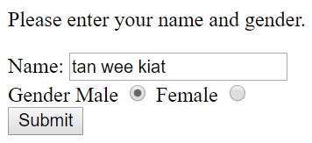 

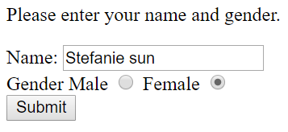 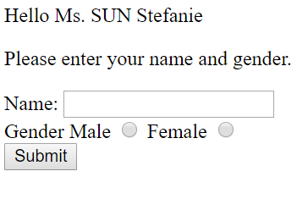

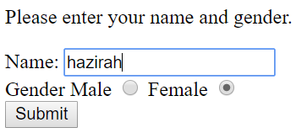 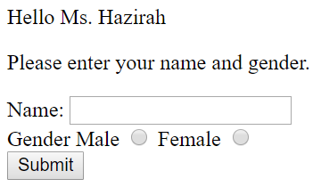

1. Write a program in a file named **str_2.php** that contains a form requesting a line of input containing an email address. **str_2.php** then displays the *first* email address contained in that line of input.

**Assumptions:**

* + An email address embedded in an input line will be surrounded by an empty space at both ends.
  + Each line of input will always contain at least one email address.

For example, given the input “Email: contact_us@smu.edu.sg” as shown below, the program will extract “contact_us@smu.edu.sg” and display it.

Below are three sample runs:



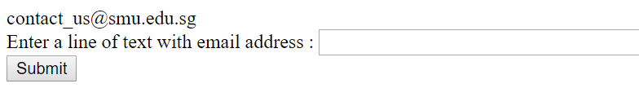



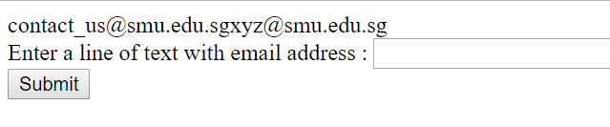

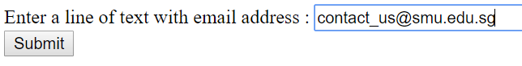

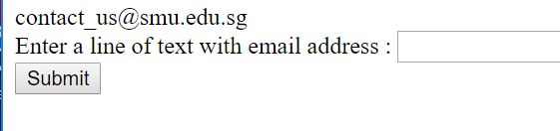

**Hint**: explore explode(), strpos()

|  |  |  |  |  |  |  |  |  |  |  |  |  |  |  |  |  |  |  |  |  |  |  |  |  |  |
| --- | --- | --- | --- | --- | --- | --- | --- | --- | --- | --- | --- | --- | --- | --- | --- | --- | --- | --- | --- | --- | --- | --- | --- | --- | --- |
| .. | .. | 5 | 6 | 7 | 8 | 9 | 10 | 11 | 12 | 13 | 14 | 15 | 16 | 17 | 18 | 19 | 20 | 21 | 22 | 23 | 24 | 25 | 26 | 27 |  |
|  |  | : |  | c | o | n | t | a | c | t | _ | u | s | @ | s | m | u | . | e | d | u | . | s | g |  |





In order to extract the first email address in the input line, you will need to locate the boundary of the email address by obtaining the index numbers of the start_index and the end_index. How can you find these two index numbers? If you think carefully, you will see that start_index marks the last space before the symbol ‘@’ while end_index marks the first space after the symbol ‘@’. Let us refer to the index of ‘@’ as symbol_index. Look for functions in the String module to find indices of start_index, end_index and symbol_index

A special scenario is when the email address is either at the very beginning or at the very end of the input line (or both). In this case, there may not be a space before (or after) the email address. To work around this, you can first concatenate a space to both ends of the input line. Thus, if the input line is “xyz@smu.edu.sg”, it becomes “ xyz@smu.edu.sg ”.

1. **str_3.php** contains a form that asks the user to enter a string, say text, and two characters, say start and end. Edit **str_3.php** that searches for a substring in text such that the substring begins with the character start and ends with the character end. If there is no such substring, display the message "No such substring".

Hint: explore substr() and strpos()

Sample runs of **str_3.php** are shown below:

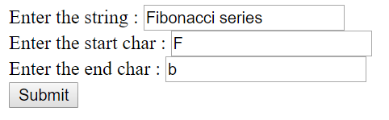 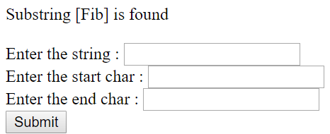

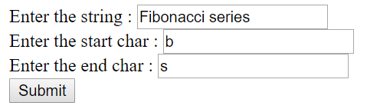 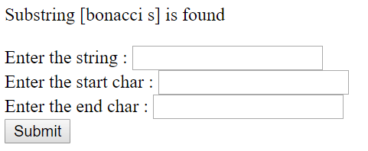

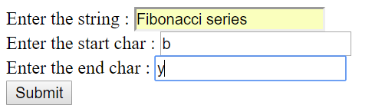 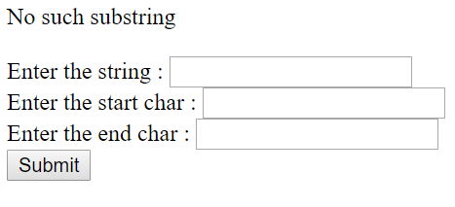

1. ** A palindrome is a string that reads the same forward or reverse. **str_4.php** contains a form that requests the user to enter a string. Edit **str_4.php** so that it displays the message “The string <*input string*> is a palindrome” if the input string is a palindrome, else print the message “The string <*input string*> is not a palindrome”. **str_4.php** should ignore digits, empty spaces or any special characters in the input string when evaluating for a palindrome.

Hint: explore preg_replace()

Sample runs of **str_4.php** are shown below:

 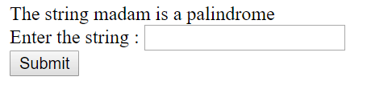

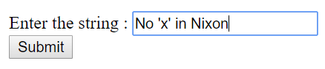 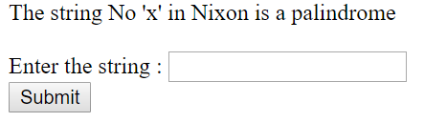

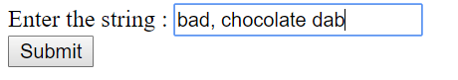 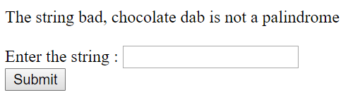

1. **str_5.php** contains a form that asks the user to enter two strings. Let us call the first string str1 and the second string str2. Edit **str_5.php** such that it displays "Bingo!" if every character in str1 also appears in str2. Otherwise, it displays "Nope :( "

Hint: explore strlen(), strpos()

Some sample runs of **str_5.php** are shown below:

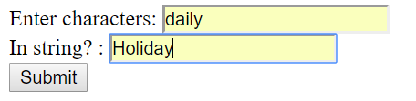 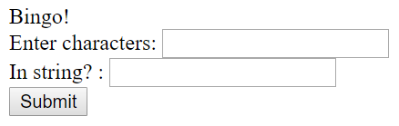

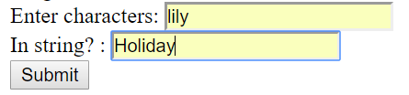 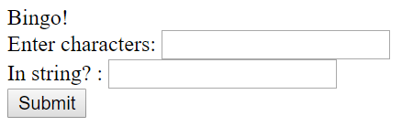

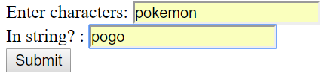 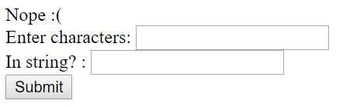

**Lab 4: Functions**

Learning Outcomes:

* Understand how to write your own functions and invoke them
* Know the difference between invoking a built-in function and function of an imported module

Instructions:

* Suggest that you create a working folder **is113\lab4** in your wamp server root. Store all your solutions in this working folder.
* Challenging questions are marked with *.

1. **fun_1.php** contains a form that accepts two integers, say n and f. Edit **fun_1.php** such that it displays whether f is a factor of n or not. You are required to implement a function called is_factor in **fun_1.php** that takes in 2 parameters n and f and returns True if f is a factor of n and False otherwise.

Assume that the user provides only integer values.

Here are the sample runs:

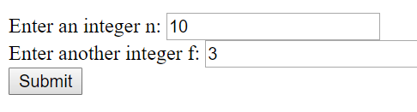 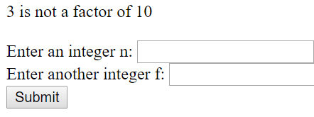

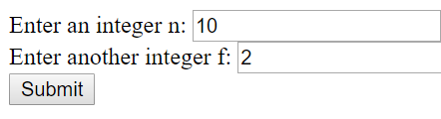 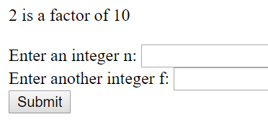

1. **fun_2.php** contains a form that accepts two integers, say m and n. Edit **fun_2.php** such that it displays the sum of the powers from m0 to mn (i.e, m0 + m1 + m2 + … + mn). In **fun_2.php**, you are required to define a function named sum_of_powers that takes in 2 parameters m and n. and computes the sum of the powers from m0 to mn and returns the sum.

Hint: explore pow()

Assume that the user provides only integer values.

Here is a sample run:

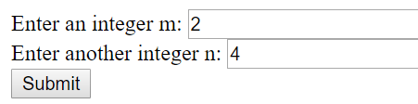 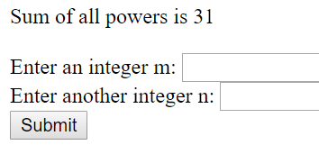

1. **fun_3.php** contains a form that accepts two integers, say min and max. Edit **fun_3.php** such that it displays all the perfect squares between min and max. For example, given min=10 and max=110, it displays the perfect squares – 16 25 36 49 64 81 100.

Assume that the user provides only integer values.

Hint: explore sqrt(), floor(), ceil(), pow()

Here is a sample run:

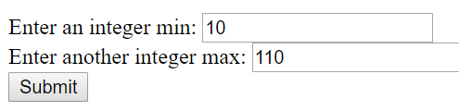 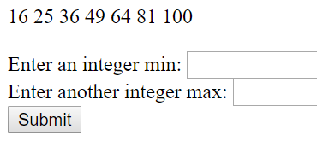

1. [ * ] A sandwich typically consists of cheese, meat or/and vegetables placed in between two slices of bread. Consider a string “remember”, the sub-string “memb” is sandwiched between “re” and its mirror “er” on the other side. In **fun_4.php**, write a function named get_sandwich that takes in a string and returns the sandwiched string, if any, or None.

Hint: explore substr()

Here are some sample outputs when **fun_4.php** is run:

 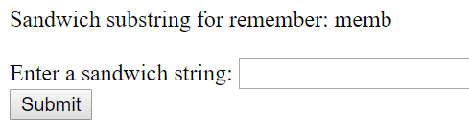

 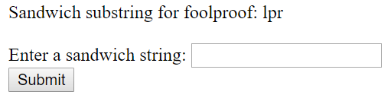

 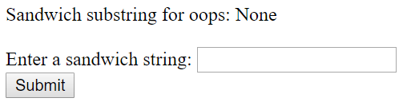

1. [ *** ] You may have written a program earlier using Caesar Cipher encoding, in which each letter is replaced by the letter that is some fixed positions away from the original letter.

Let us use another simple form of encoding wherein each letter is replaced by its hexadecimal form (<https://www.wikihow.com/Understand-Hexadecimal>). Each of the a-z alphabets, digits 0-9 and special characters ( like , or . or space or ! ) are converted to a hex form using UTF-8 encoding as seen in ASCII table. There are many Text to Hex converters online. Example: <https://www.online-toolz.com/tools/text-hex-convertor.php>. You can test your encoding program using the online convertor.

In **fun_5.php** define two functions called encode and decode. The function encode takes in a string and returns the encoded string in hexadecimal format. The function decode, on the other hand takes in the encoded string in hexadecimal format and returns the original string.

You can assume that the string passed into the function encode contains only valid characters from a-z or A-Z and punctuation symbols. You can also assume that a valid encoded string is passed into the function decode, i.e. every 2 characters represent the hexadecimal form corresponding to the original character.

Here are sample outputs when **fun_5** is run:

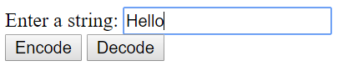 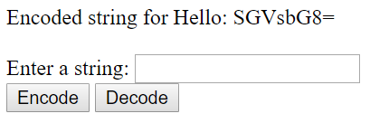

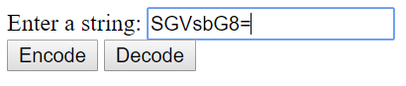 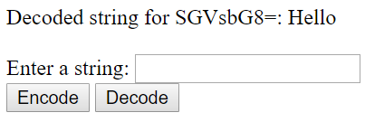

**Lab 5: Indexed Arrays**

Learning Outcomes:

* Get familiar with using indexed array
* Get to know to modify arrays, add, remove elements from arrays
* Get to solve problems using arrays

Instructions:

* Suggest that you create a working folder **is113\lab5** in your **wamp server**. Store all your solutions in this working folder.
* Challenging questions are marked with *.

1. Examine **arr_1.php** given to you. Complete the function get_numbers to return a new array that contains only integers between min and max parameters, inclusively. Your code should not modify the original array.

Here is a sample output when **arr_1.php** is run (with the given test code):

|  |
| --- |
| Original array: [4, 10, 12, 28, 24, 18, 5, 20, 15, 21, 30, 22, 21, 14, 17, 28, 26, 24, 6, 8, 15]  After function is called [10, 12, 18, 20, 15, 14, 17, 15] |

1. * **arr_2.php** contains a form that gets 10 integer inputs from the user. It should then display the minimum, maximum and median of all numbers entered.

Note: The median is the middle of list of numbers. For example, median of numbers 12, 4, 5 is 5. In case of odd amount of numbers, the median is the exact middle number of numbers when arranged sorted. In case of even amount of numbers, we would get a pair of middle numbers. The median is half way between them. As an example, median of numbers 6, 12, 4, 10 is 8 (6 + 10) / 2 because when placed in order the middle numbers would be 6 and 10.

Hint: explore sort()

Here is a sample run:

fn1 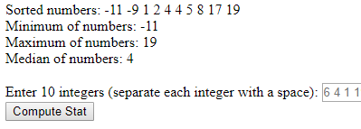

1. In **arr_3.php** write a function called count_numbers that takes in a multidimensional array, say $numbers, containing numbers and arrays that contain numbers. It returns the count of numbers in the array $numbers. Note that your function has to cater to the possibility of $numbers having an array of numbers. You can assume that it is at the most a 2-dimensional array.

Hint: explore is_array()

Here are some examples:

|  |
| --- |
| $numbers = [4,6,[1,2],10,[-1,-3]];  Count of numbers:7  $numbers = [4, 6, [1,2,3,4], 10, [-1,-3], [5,7,1,2]];  Count of numbers:13 |

**Lab 6: Loop structure (any loop structure is allowed)**

Learning Outcomes:

* Get familiar with using loop structure
* Get to solve problems using functions, conditional structure, for, foreach or while loop structure

**5. [ ** ]** Counting in binary is similar to counting in any other number system. Beginning with a single digit, counting proceeds through each symbol, in increasing order. Decimal (or base-10) counting uses the symbols **0** through **9**, while binary only uses the symbols **0** and **1.** Read more about how a decimal number can be converted to its binary equivalent:

· <http://www.is.wayne.edu/olmt/binary/page3.htm>

· <http://www.wikihow.com/Convert-from-Decimal-to-Binary>

Let us see the method to convert decimal number 32(base 10) to its binary equivalent.

32 divided by 2 gives 16 and remainder **0**

16 divided by 2 gives 8 and remainder **0**

8 divided by 2 gives 4 and remainder **0**

4 divided by 2 gives 2 and remainder **0**

2 divided by 2 gives 1 and remainder **0**

1 divided by 2 gives 0 and remainder **1**

Do you notice that you are dividing the given decimal number by 2 and subsequently in every iteration, the quotient is divided by 2. The binary number is the sequence of remainders in reverse, from the bottom remainder to the top remainder.

Write a program in a file named **lab6_6.php** that converts a positive integer number (received from a HTML form) to its binary equivalent following the procedure explained above. You can check if your conversion is correct using the built-in function.

Try the built-in function decbin in PHP that converts decimal number to its binary equivalent.

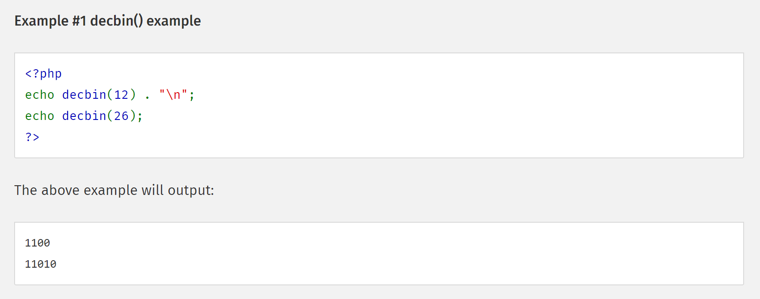

From: <http://php.net/manual/en/function.decbin.php>

Sample run of the program is shown below:

|  |
| --- |
| Input decimal number is 32  Binary equivalent of 32 is 100000 |

8. **[ *** ]** Define a function called **merge()** that merges two associative arrays containing key-value pairs representing people. Each key-value pair in the association array represents one person’s name and age and the list is sorted in increasing order of people’s age.

The function merges the two lists into a single list in which the people are still ordered by their age.

Note: You are NOT allowed to use any sort function.

For example, if

$list1 = ["John"=>12, "Kate"=>15, "Henry"=>35], and

$list2 = ["Mike"=>18, "Scott"=>20, "Joseph"=>48, "Larry"=>54]

When invoked like this:

var_dump(merge($list1, $list2))

The output would be:

|  |
| --- |
| array (size=7)  'John' => int 12  'Kate' => int 15  'Mike' => int 18  'Scott' => int 20  'Henry' => int 35  'Joseph' => int 48  'Larry' => int 54 |

**Note:** You are allowed to make your own assumptions

**Lab 8: Dictionaries (Associative Arrays)**

1. [*] Complete the function compute_bill in the file that takes in a dictionary of items purchased by the customer, and price of items and returns the amount to be paid.

|  |  |
| --- | --- |
| 01  02  03  04  05  06  07  08  09  10  11  12  13  14  15  16  17  18  19  20  21  22 | <?php  $price_info = [  'pencil'=> 0.80,  'pen' => 1.20,  'eraser' => 0.50  ];    #complete this function  function compute_bill($cart, $pricing){    }    $jane_items = ['pen'=>10, 'eraser'=>2];  $eric_items = ['pencil'=>12, 'eraser'=>5, 'pen'=>2];    echo "Jane's bill amount $" . compute_bill($jane_items, $price_info);  echo "Eric's bill amount $" . compute_bill($eric_items, $price_info);  ?> |

Here is the expected output (with the given test data):

|  |
| --- |
| Jane's bill amount $ 13  Eric's bill amount $ 14.5 |

4. [**] In a file named **lab8_4.php**, copy the code shown below. Write a function called reverse_dict in the file that takes in a dictionary and reverses the dictionary. That is, you are supposed to return a new dictionary that creates keys out of values and values out of keys. You can assume that the input to the functions consists of dictionary whose values are indexed arrays (aka. lists).

|  |  |
| --- | --- |
| 01  02  03  04  05  06  07  08  09  10  11  12  13  14  15  16  17  18  19  20  21  22  23  24  25  26  27  28 | <?php  #write the function  $dict1 = reverse_dict(["a"=>[1,2,3], "b"=>[1,2], "c"=>[3,4], "d"=>[5,6]]);  $student_subjects = reverse_dict(["Jane"=>["Economics","Physics","Chemistry"], "Mark"=>["Literature","Chemistry","Biology"], "Sarah"=>["Literature","Physics","Chemistry"]]);    var_dump($dict1);  var_dump($student_subjects);  ?> |

Here is the output when **lab8_4** is run (with the given two test data):

|  |
| --- |
| C:\wamp64\www\is111\lab8\ex4.php:5: **array** *(size=6)*  1 =>   **array** *(size=2)*  0 => string 'a' *(length=1)*  1 => string 'b' *(length=1)*  2 =>   **array** *(size=2)*  0 => string 'a' *(length=1)*  1 => string 'b' *(length=1)*  3 =>   **array** *(size=2)*  0 => string 'a' *(length=1)*  1 => string 'c' *(length=1)*  4 =>   **array** *(size=1)*  0 => string 'c' *(length=1)*  5 =>   **array** *(size=1)*  0 => string 'd' *(length=1)*  6 =>   **array** *(size=1)*  0 => string 'd' *(length=1)*  C:\wamp64\www\is111\lab8\ex4.php:6: **array** *(size=5)*  'Economics' =>   **array** *(size=1)*  0 => string 'Jane' *(length=4)*  'Physics' =>   **array** *(size=2)*  0 => string 'Jane' *(length=4)*  1 => string 'Sarah' *(length=5)*  'Chemistry' =>   **array** *(size=3)*  0 => string 'Jane' *(length=4)*  1 => string 'Mark' *(length=4)*  2 => string 'Sarah' *(length=5)*  'Literature' =>   **array** *(size=2)*  0 => string 'Mark' *(length=4)*  1 => string 'Sarah' *(length=5)*  'Biology' =>   **array** *(size=1)*  0 => string 'Mark' *(length=4)* |